GURU NANAK DEV ENGINEERING COLLEGE, LUDHIANA

**DEPARTMENT OF INFORMATION TECHNOLOGY**

WEB TECHNOLOGIES

FOURTH SEMESTER

**Session: January-June 2021**

**Batch: 2019-2023**



Submitted By: Submitted to:

Lokesh Dhingra (1905359) Ms. Hanit Kaur

**Department of Information Technology,**

**Guru Nanak Dev Engineering College**

**Ludhiana-141106**

**INDEX**

|  |  |  |
| --- | --- | --- |
| **SR. NO** | **PRACTICAL** | **PAGE NO.** |
| 1. | *Create a simple web pages by writing HTML using a simple text editor, notepad. Demonstrate the following components of the web page: Page title and headings Paragraph and inline images* | 3 |
| 2. | *Demonstrate the use of links, lists, and tables in html. You should be able to link separate pages and create named links within a document, using them to build a “table of contents”.* | 4-8 |
| 3. | *Create a simple forms in HTML and demonstrate the use of various form elements like input box, textarea, submit and radio buttons etc.* | 9-12 |
| 4. | *Demonstrate the use of cascading style sheets (CSS) (inline, internal and external) to specify various aspects of style, such as colours and text fonts and sizes, in html document* | 13-14 |
| 5. | *Creation of web pages using HTML5 and CSS3* | 15-18 |
| 6. | *Demonstrate the use of bootstrap framework* | 19-22 |
| 7. | *Creating a web page using php* | 23-25 |

**Practical 1**

**Aim:** *Create a simple web pages by writing HTML using a simple text editor, notepad. Demonstrate the following components of the web page: Page title and headings Paragraph and inline images*

**Code: HTML CODE**

<!DOCTYPE *html*>

<html>

<head>

    <title>Practical 1</title>

</head>

<body>

<h1 *style*=" font-weight: bold;

font-size: 45px;

color:brown; text-align: center; text-decoration: none;">

    Welcome

</h1>

<h3 *style*=" font-weight: bold;

font-size: 20px;

color:indigo; text-align: center; text-decoration: none; text-transform: uppercase;">IN THIS PAGE h and p tags are used</h3>

<p>

Guru Nanak Dev Engineering College, one of the prestigious, oldest and minority institution of Northern India, was established under the aegis of Nankana Sahib Education Trust (NSET) in 1956. NSET was founded in memory of the most sacred temple of Nankana Sahib, birth place of Guru Nanak Dev Ji. Shiromani Gurudwara Prabandhak Committee, Amritsar, a premier organization of universal brotherhood, which is the main force behind the mission of "Removal of Economic Backwardness through Technology" and NSET with the same mission, established a Polytechnic in 1953 and Guru Nanak Dev Engineering College (GNDEC) in 1956. The Trust deed was registered on 24th February 1953 with a commitment by Nankana Sahib Education Trust to uplift the vast weaker section of Indian polity comprising Rural India by admitting 70% students every year from Rural Areas. This commitment was made to the nation on 8th April, 1956. The day when foundation stone of the College was laid by Late Dr. Rajendra Prasad Ji, the First President of India.

</p>

</body>

</html>

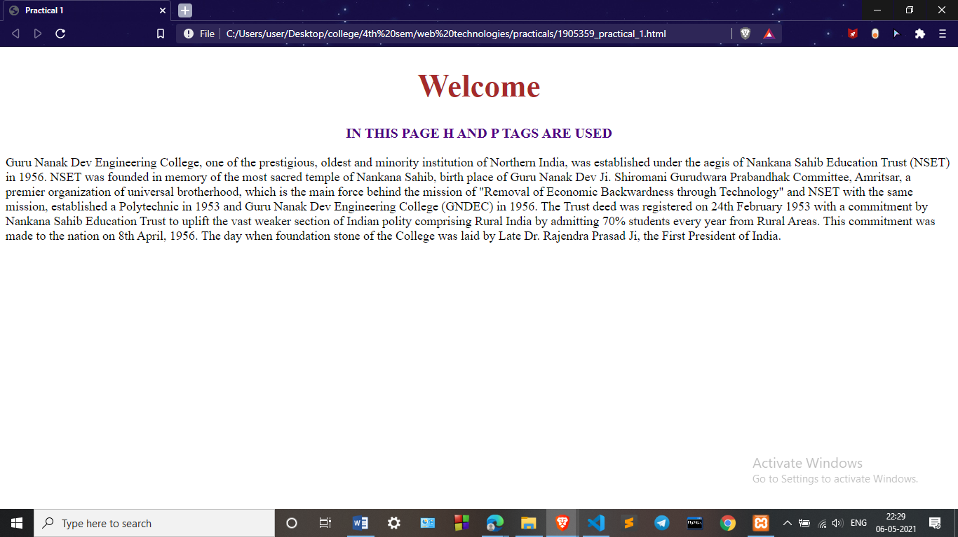**OUTPUT-**

**Practical 2**

**Aim:** *Demonstrate the use of links, lists, and tables in html. You should be able to link separate pages and create named links within a document, using them to build a “table of contents”.*

**Code: HTML CODE MAIN PAGE**

<!DOCTYPE *html*>

<html>

<head>

    <title>Practical 2</title>

    <link *rel*="stylesheet" *type*="text/css" *href*="1905359_practical_2.css">

</head>

<body>

    <h1>GURU NANAK DEV ENGINEERING COLLEGE</h1>

    <p><b>Guru Nanak Dev Engineering college has a lot of branches like Computer science department , Information Technology Department and Production Enginering deparment.</p>

    <table>

      <tr>

        <th>Departments</th>

        <th>Head of Department</th>

        <th>Subjects</th>

      </tr>

      <tr>

        <td>Computer science</td>

        <td>Dr. Parminder Singh</td>

        <td><a *href*="1905359_practical_2_cse.html" *target*="_blank">Computer Science Department</a></td>

      </tr>

      <tr>

        <td>Information Technology</td>

        <td>Dr. Kulvinder Singh Mann</td>

        <td><a *href*="1905359_practical_2_it.html" *target*="_blank">Information Technology</a></td>

      </tr>

    <tr>

        <td>Mechanical Engineering</td>

        <td>Dr. Paramjit Singh Bilga</td>

        <td><a *href*="1905359_practical_2_mechanical.html" *target*="_blank">Mechanical Department</a></td>

      </tr>

    </table>

    <h2>SUBJECTS OF COMPUTER SCIENCE</h2>

    <ol>

      <li>DIGITAL CIRCUIT</li>

      <li>DATA COMMUNICATION</li>

      <li>DATA STRUCTURES</li>

    </ol>

    <h2>SUBJECTS OF INFORMATION TECHNOLOGY</h2>

    <ol>

      <li>COMPUTER ARCHICHECTURE</li>

      <li>PROBABILITY AND STATISTICS</li>

      <li>OPERATING SYSTEMS</li>

    </ol>

    <h2>SUBJECTS OF MECHANICAL ENGINEERING</h2>

    <ol>

      <li>THEORY OF MACHINE</li>

      <li>MODERN MANUFACTURING</li>

      <li>APPLIED THERMODYNAMICS</li>

    </ol>

</body>

</html>

**HTML CODE MECHANICAL ENGINEERING DEPARTENT**

<!DOCTYPE *html*>

<html>

<head>

    <title>Practical 2 Mechanical department</title>

</head>

<body>

<h1 *style*=" font-weight: bold;

font-size: 45px;

color:brown; text-align: center; text-decoration: none;">

    Welcome To Mechanical Department

</h1>

<p>

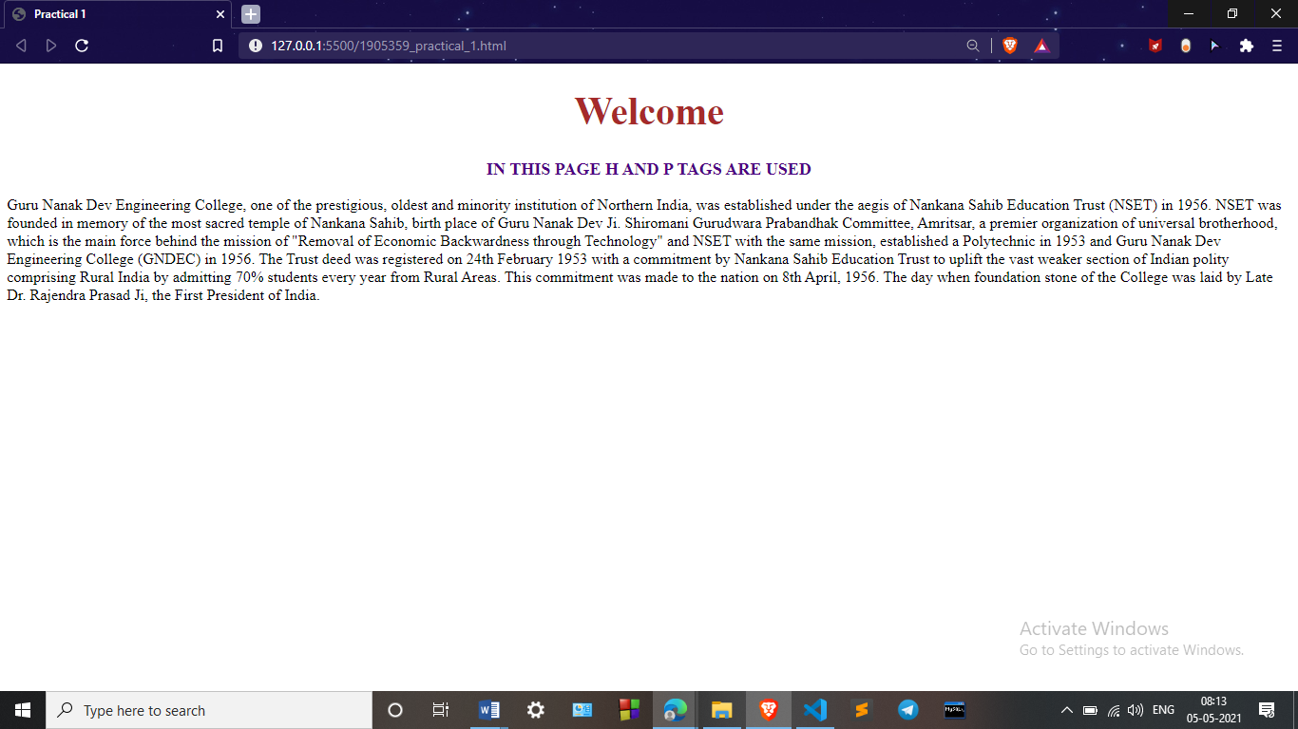    Department of Mechanical Engineering was established in 1957. Since its inception, the department has contributed in a big way to the society by providing technical manpower for various fields in India and abroad. Around 4000 graduates and 300 post graduates from the department are settled in very good positions all over the Globe. At present, the department is proud to get best merit students in the region. The faculty of the department continues to provide new frontiers of technical knowledge to the students by imparting quality education and research. The UG course is keeping pace with the latest developments in engineering education. Courses offered by the department are AICTE approved. Presently, Dr. Paramjit Singh Bilga is Head of Department.

</p>

</body>

</html>

**HTML CODE INFORMATION TECHNOLOGY DEPARTMENT**

<!DOCTYPE *html*>

<html>

<head>

    <title>Practical 2 IT department</title>

</head>

<body>

<h1 *style*=" font-weight: bold;

font-size: 45px;

color:brown; text-align: center; text-decoration: none;">

    Welcome To Information Technology Department

</h1>

<p>

    This Department was established in 2001. The mission of the Department of Information Technology is to impart high quality post graduate and under-graduate education and carry out leading-edge research in the discipline of Information Technology. The department currently runs academic program leading to the award of B.Tech. in Information Technology degree of Punjab Technical University Jalandhar. The Department has various laboratories equipped with state-of-the-art computing facilities to support the research and teaching activities. A library with a lot of books on Information Technology for the exclusive use of the faculty and students is located in the premises of the Department. At present Dr. Kiran Jyoti is Head of the Department.

</p>

</body>

</html>

**HTML CODE COMPUTER SCIENCE DEPARTMENT**

<!DOCTYPE *html*>

<html>

<head>

    <title>Practical 2 CSE department</title>

</head>

<body>

<h1 *style*=" font-weight: bold;

font-size: 45px;

color:brown; text-align: center; text-decoration: none;">

    Welcome To Computer Sciense and Engineering Department

</h1>

<p>

    Department of Computer Science and Engineering is established in year 1997. Department is offering B.Tech. and M.Tech. programs in Computer Science and Engineering. Laboratories of the department are equipped with state of the art infrastructure to cater course work and research activities. A Good number of books is available in departmental library for prompt access to students and faculty members. Under academic autonomy, study schemes of the offered programs are updated regularly focusing outcome based education, to make students employable as per national and international requirements. Graduates of the department are serving around the globe in eminent companies, academia, as well as in public sector. They are bringing laurel to the department by excelling in fields of their work. Every year a good number of students are clearing different competitive exams.

</p>

</body>

</html>

**CSS CODE MAIN PAGE**

table, th, td{

    border: 3px solid black;

    text-align: center;

    vertical-align: bottom;

    text-decoration: none;

}

td{

    height: 40px;

}

h2{

    font-size: 18px;

    font-weight: bold;

    color:brown;

}

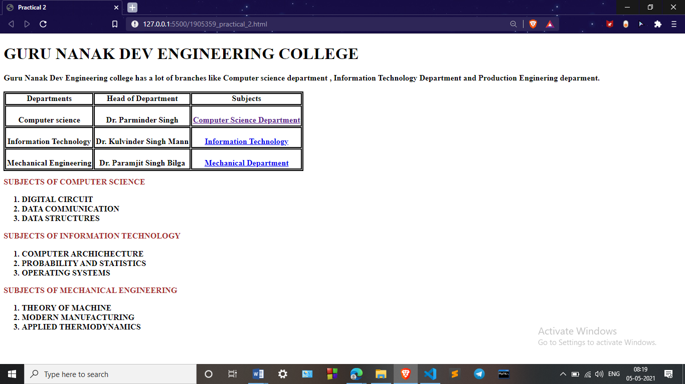**OUTPUT-**

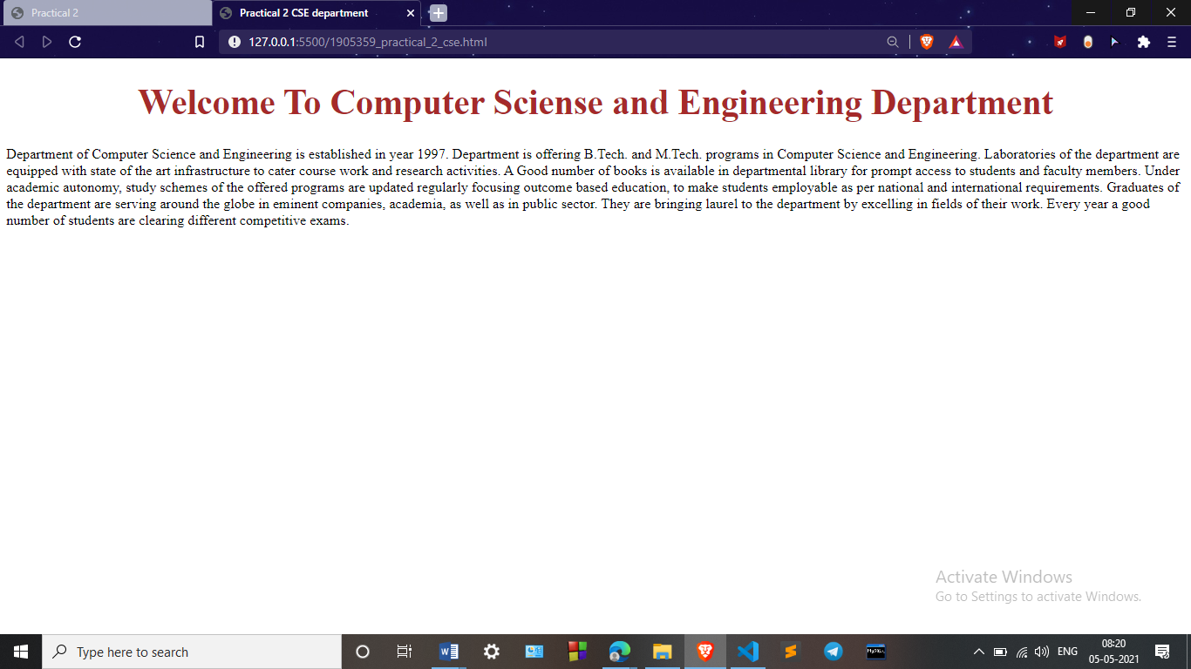<!

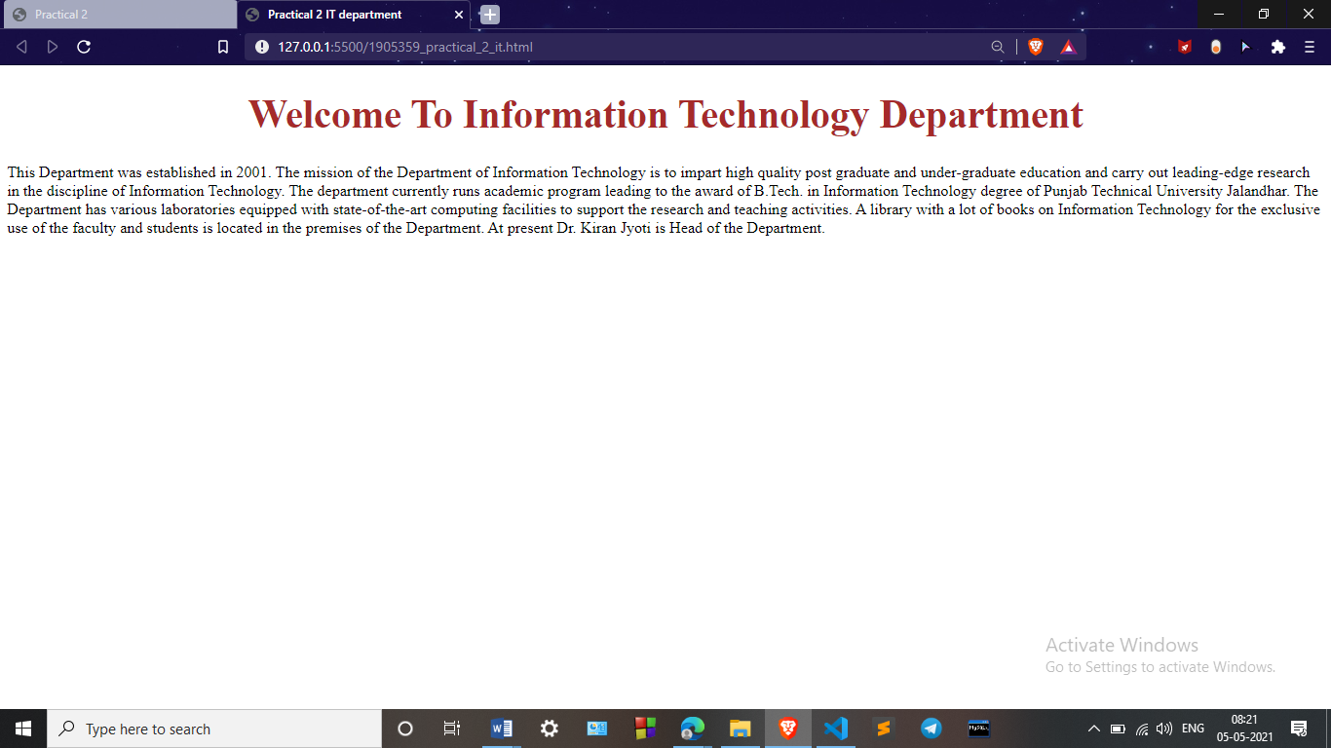

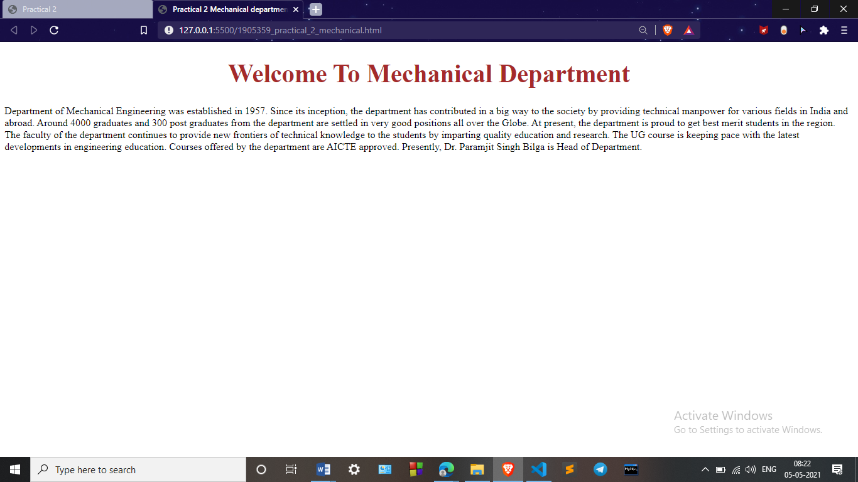

**Practical 3**

**Aim:** *Create a simple forms in HTML and demonstrate the use of various form elements like input box, textarea, submit and radio buttons etc.*

**Code: HTML CODE**

<!DOCTYPE *html*>

<html *lang*="en">

<head>

    <link *rel*="stylesheet" *href*="1905359_practical_3.css" *type*="text/css">

    <title>Practical 3</title>

    <meta *charset*="UTF-8">

    <meta *http-equiv*="X-UA-Compatible" *content*="IE=edge">

    <meta *name*="viewport" *content*="width=device-width, initial-scale=1.0">

</head>

<body>

    <div *class*="form1">

        <form>

            <fieldset>

                <legend><span *class*="number">1</span>Candidate Info</legend>

                <input *type*="text" *name*="field1" *placeholder*="Your Name * "><br>

                <input *type*="email" *name*="field3" *placeholder*="Your Email * "><br>

                <label>Gender: </label>

                <label *for*="male"><span><input *type*="radio" *id*="male" *name*="gender" *value*="male">Male</span></label>

                <label *for*="female"><span><input *type*="radio" *id*="female" *name*="gender" *value*="female">Female</span></label>

                <label *for*="other"><span><input *type*="radio" *id*="other" *name*="gender" *value*="other">Other</span></label>

                <textarea *name*="field3" *placeholder*="Describe Yourself"></textarea><br>

                <label *for*="job">Interests: </label>

                <select *name*="field4" *id*="job">

                    <optgroup *label*="Indoors">

                        <option *value*="Fishkeeping">Fishkeeping</option>

                        <option *value*="Reading">Reading</option>

                        <option *value*="Boxing">Boxing</option>

                        <option *value*="Debate">Debate</option>

                        <option *value*="Gaming">Gaming</option>

                        <option *value*="Snooker">Snooker</option>

                        <option *value*="Other_indoor">Other</option>

                    </optgroup>

                    <optgroup *label*="Outdoors">

                        <option *value*="Football">Football</option>

                        <option *value*="Swimming">Swimming</option>

                        <option *value*="Fishing">Fishing</option>

                        <option *value*="Climbing">Climbing</option>

                        <option *value*="Cycling">Cycling</option>

                        <option *value*="Other_indoor">Other</option>

                    </optgroup>

                </select>

            </fieldset>

            <fieldset>

                <legend><span *class*="number">2</span>Candidate Info</legend>

                <textarea *name*="field3" *placeholder*="About Your school: "></textarea>

            </fieldset>

            <input *type*="submit" *value*="Submit">

        </form>

    </div>

</body>

</html>

**CSS CODE**

*.form1*{

    max-width: 500px;

    padding: 10px 20px;

    background:lightgoldenrodyellow;

    margin: 50px 500px;

    padding: 20px;

    border-radius: 8px;

    font-family: Georgia, 'Times New Roman', Times, serif;

}

*.form1* fieldset{

border:2px solid crimson;

}

*.form1* legend{

    font-size: 1.4em;

    margin-bottom: 10px;

}

*.form1* label{

    display: block;

    margin-bottom: 8px;

}

*.form1* input[*type*="text"],

*.form1* input[*type*="email"],

*.form1* input[*type*="date"],

*.form1* input[*type*="datetime"],

*.form1* input[*type*="number"],

*.form1* input[*type*="search"],

*.form1* input[*type*="url"],

*.form1* input[*type*="time"]

{

    font-family: Georgia, 'Times New Roman', Times, serif;

    background:gainsboro;

    border: 1px darkblue  solid;

    border-radius: 4px;

    font-size: 15px;

    margin-bottom: 10px;

    outline:teal;

    padding-left: 5px;

    margin-left: 2px;

    padding: 10px;

    width: 100%;

    box-sizing: border-box;

*-webkit-box-sizing*: border-box;

*-moz-box-sizing*: border-box;

    background-color: whitesmoke;

    align-items: center;

}

*.form1* input[*type*="text"]*:focus*,

*.form1* input[*type*="email"]*:focus*,

*.form1* input[*type*="date"]*:focus*,

*.form1* input[*type*="datetime"]*:focus*,

*.form1* input[*type*="number"]*:focus*,

*.form1* input[*type*="search"]*:focus*,

*.form1* input[*type*="url"]*:focus*,

*.form1* input[*type*="time"]*:focus*

*.form1* textarea*:focus*,

*.form1* select*:focus*{

    background-color: gainsboro;

}

*.form1* select{

*-webkit-appearance*: menulist-button;

    height: 35px;

}

*.form1* *.number*{

    background:teal;

    color:whitesmoke;

    height: 30px;

    width: 30px;

    display: inline-block;

    font-size: 0.8em;

    margin-right: 4px;

    line-height: 30px;

    text-align: center;

    text-shadow: 0 1px 0 rgba(255, 255, 255, 0.2);

    border-radius: 15px 15px 15px 0;

}

*.form1* input[*type*="submit"],

*.form1* input[*type*="button"]{

    position: relative;

    display: block;

    padding: 19px 39px 18px 39px;

    color:cornsilk;

    color:maroon;

    margin: 20px auto;

    border-radius: 4px;

    background: mintcream;

    font-size: 18px;

    text-align: center;

    font-style:normal;

    font-weight: bold;

    width: 100%;

    border: 1px darkslategrey solid;

    border-width: 2px 2px 4px;

    margin-bottom: 10;

}

*.form1* input[*type*="submit"]*:hover*,

*.form1* input[*type*="button"]*:hover*{

    background: lavender;

}

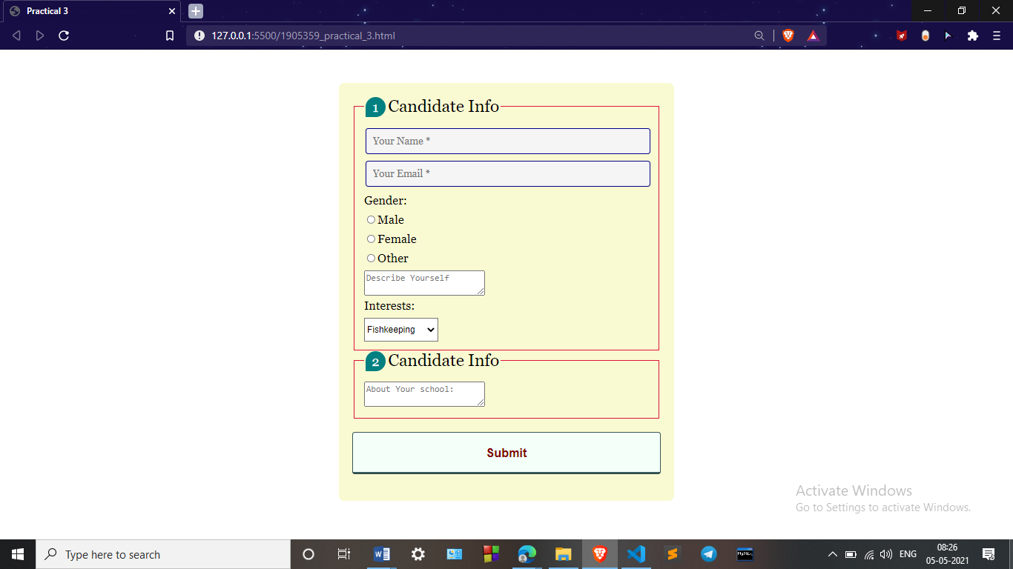**OUTPUT-**

**Practical 4**

**Aim:** *Demonstrate the use of cascading style sheets (CSS) (inline, internal and external) to specify various aspects of style, such as colours and text fonts and sizes, in html document.*

**Code: HTML CODE**

<!DOCTYPE *html*>

<html *lang*="en">

<head>

    <meta *charset*="UTF-8">

    <meta *http-equiv*="X-UA-Compatible" *content*="IE=edge">

    <meta *name*="viewport" *content*="width=device-width, initial-scale=1.0">

    <link *rel*="stylesheet" *href*="1905359_practical_4.css">

    <title>Practical 4</title>

    <style>

*#internal-css*{

    font-family: Arial, Helvetica, sans-serif;

    font-size: 18px;

    color: crimson;

    font-weight: bold;

    }

    h2{

        text-align: center;

        color:midnightblue;

        font-size: 22px;

        font-weight: bold;

    }

    </style>

</head>

<body>

    <h2>INLINE CSS</h2>

    <p *style*="font-family: Arial, Helvetica, sans-serif; font-size: 18px; color: darkblue; font-weight: bold;">Lorem Ipsum is simply dummy text of the printing and typesetting industry.

        Lorem Ipsum has been the industry's standard dummy text ever since the 1500s,

        when an unknown printer took a galley of type and scrambled it to make a type specimen book.

        It has survived not only five centuries, but also the leap into electronic typesetting,

        remaining essentially unchanged. It was popularised in the 1960s with the release of Letraset sheets containing

        Lorem Ipsum passages, and more recently with desktop publishing software like Aldus PageMaker including versions

        of Lorem Ipsum.

    </p>

    <br>

    <h2>INTERNAL CSS</h2>

    <p *id*="internal-css">Lorem Ipsum is simply dummy text of the printing and typesetting industry.

        Lorem Ipsum has been the industry's standard dummy text ever since the 1500s,

        when an unknown printer took a galley of type and scrambled it to make a type specimen book.

        It has survived not only five centuries, but also the leap into electronic typesetting,

        remaining essentially unchanged. It was popularised in the 1960s with the release of Letraset sheets containing

        Lorem Ipsum passages, and more recently with desktop publishing software like Aldus PageMaker including versions

        of Lorem Ipsum.

    </p>

    <br>

    <h2 >EXTERNAL CSS</h2>

    <p *id*="external-css">Lorem Ipsum is simply dummy text of the printing and typesetting industry.

        Lorem Ipsum has been the industry's standard dummy text ever since the 1500s,

        when an unknown printer took a galley of type and scrambled it to make a type specimen book.

        It has survived not only five centuries, but also the leap into electronic typesetting,

        remaining essentially unchanged. It was popularised in the 1960s with the release of Letraset sheets containing

        Lorem Ipsum passages, and more recently with desktop publishing software like Aldus PageMaker including versions

        of Lorem Ipsum.

    </p>

</body>

</html>

**CSS CODE**

*#external-css*{

    font-family: Arial, Helvetica, sans-serif;

    font-size: 18px;

    color:darkred;

    font-weight: bold;

    }

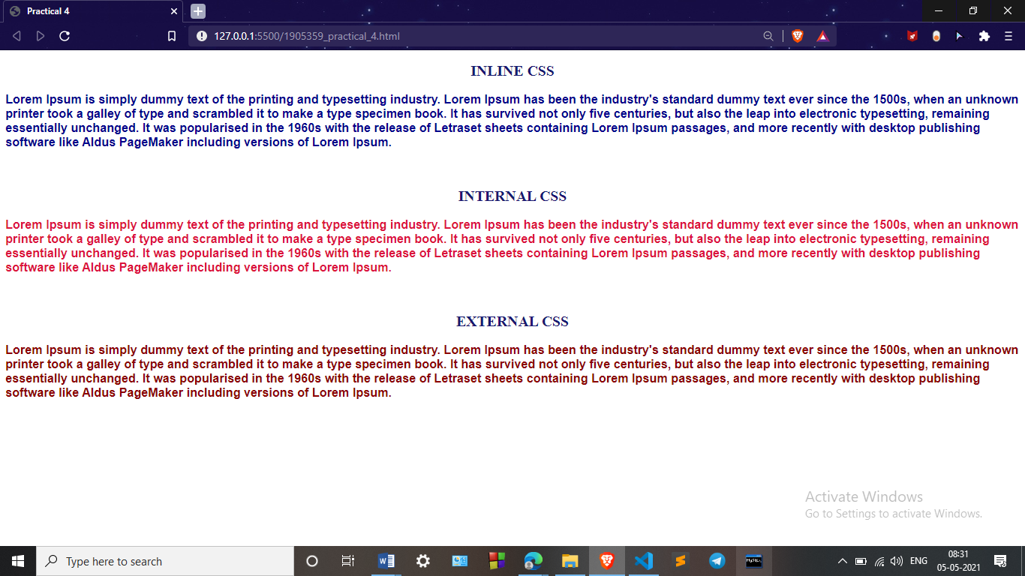**OUTPUT-**

**Practical 5**

**Aim:** *Creation of web pages using HTML5 and CSS3*

**Code: HTML CODE**

<!DOCTYPE *html*>

<html *lang*="en">

<head>

    <meta *charset*="UTF-8">

    <meta *http-equiv*="X-UA-Compatible" *content*="IE=edge">

    <meta *name*="viewport" *content*="width=device-width, initial-scale=1.0">

    <link *rel*="stylesheet" *href*="1905359_practical_5.css">

    <title>Practical 5</title>

</head>

<body>

    <header *id*="showcase">

        <h1>Welcome to the beach</h1>

        <p>Lorem ipsum dolor sit amet, consectetur adipisicing elit.

        Modi officiis ipsum officia numquam expedita ullam</p>

        <a *href*="#" *class*="button">Read More</a>

    </header>

    <section *class*="section_a">

        <p>

            Lorem ipsum dolor sit amet, consectetur adipisicing elit. Fugit minus impedit maxime,

            quae soluta quis cumque perferendis! Doloribus quaerat, placeat iste facere, aspernatur

            ex cum veritatis laudantium, officia, non porro exercitationem incidunt quis dolore?

            Officia ex accusamus expedita optio, voluptatem minus? In maiores omnis aperiam earum

            ab molestiae beatae laborum blanditiis incidunt, delectus dolor, id voluptates optio

            aspernatur aliquam saepe atque labore? Tempore reprehenderit ab ipsam perspiciatis ut,

            provident perferendis sapiente in numquam blanditiis, enim, illo error nulla incidunt

            quos quidem ratione repellat ipsa molestias veritatis? Mollitia, fugit dolore commodi

            porro repudiandae atque, eos, ipsum quam culpa fuga deleniti quae.

        </p>

    </section>

    <section *class*="section_b">

        <p>

            Lorem ipsum dolor sit amet, consectetur adipisicing elit. Fugit minus impedit maxime,

            quae soluta quis cumque perferendis! Doloribus quaerat, placeat iste facere, aspernatur

            ex cum veritatis laudantium, officia, non porro exercitationem incidunt quis dolore?

            Officia ex accusamus expedita optio, voluptatem minus? In maiores omnis aperiam earum

            ab molestiae beatae laborum blanditiis incidunt, delectus dolor, id voluptates optio

            aspernatur aliquam saepe atque labore? Tempore reprehenderit ab ipsam perspiciatis ut,

            provident perferendis sapiente in numquam blanditiis, enim, illo error nulla incidunt

            quos quidem ratione repellat ipsa molestias veritatis? Mollitia, fugit dolore commodi

            porro repudiandae atque, eos, ipsum quam culpa fuga deleniti quae.

        </p>

    </section>

    <section *id*="section_c">

        <div *class*="box_1">

            Lorem ipsum dolor sit amet, consectetur adipisicing elit.

            Modi officiis ipsum officia numquam expedita ullam!

        </div>

        <div *class*="box_2">

            Lorem ipsum dolor sit amet, consectetur adipisicing elit.

            Modi officiis ipsum officia numquam expedita ullam!

        </div>

        <div *class*="box_3">

            Lorem ipsum dolor sit amet, consectetur adipisicing elit.

            Modi officiis ipsum officia numquam expedita ullam!

        </div>

    </section>

</body>

</html>

**CSS CODE**

*{

    margin:0;

    padding: 0;

}

body{

    margin: 0;

    font-family: Arial, Helvetica, sans-serif;

    font-size: 19px;

    color:peru;

    line-height: 1.6;

}

*#showcase*{

    background-image: url("1905359_practical_5_bg.jpg");

    background-size: cover;

    background-position: center;

    height:100vh;

    display: flex;

    justify-content: center;

    flex-direction: column;

    align-items: center;

    text-align: center;

    padding: 0 20px;

}

*#showcase* h1{

    font-size: 50px;

    line-height: 1.2;

}

*#showcase* p{

    font-size: 20px;

}

*#showcase* *.button*{

    font-size: 18px;

    text-decoration: none;

    color:peru;

    border: peru 2px solid;

    padding: 10px 20px;

    border-radius: 4px;

    margin-top: 25px;

}

*#showcase* *.button:hover*{

    background-color: #cd853f;

    color:#fff;

}

*.section_a*{

    padding: 20px;

    background: peru;

    color:whitesmoke;

    text-align: center;

}

*.section_b*{

    padding: 20px;

    background: #f4f4f4;

    text-align: center;

}

*#section_c*{

    display: flex;

}

*#section_c* div{

    padding: 20px;

}

*#section_c* *.box_1*,*#section_c* *.box_3*{

    background: peru;

    color: whitesmoke;

}

*#section_c* *.box_2*{

    background-color: #f9f9f9;

}

**OUTPUT-**

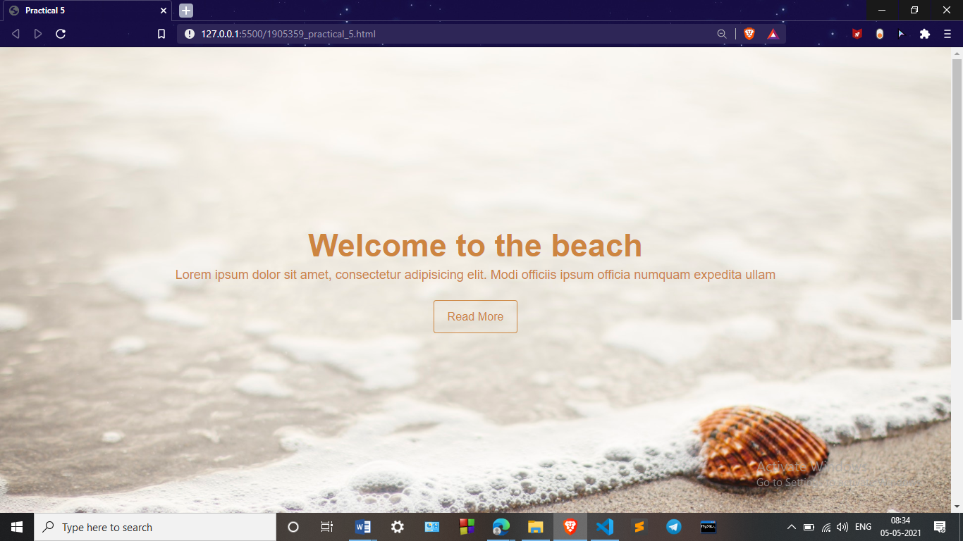

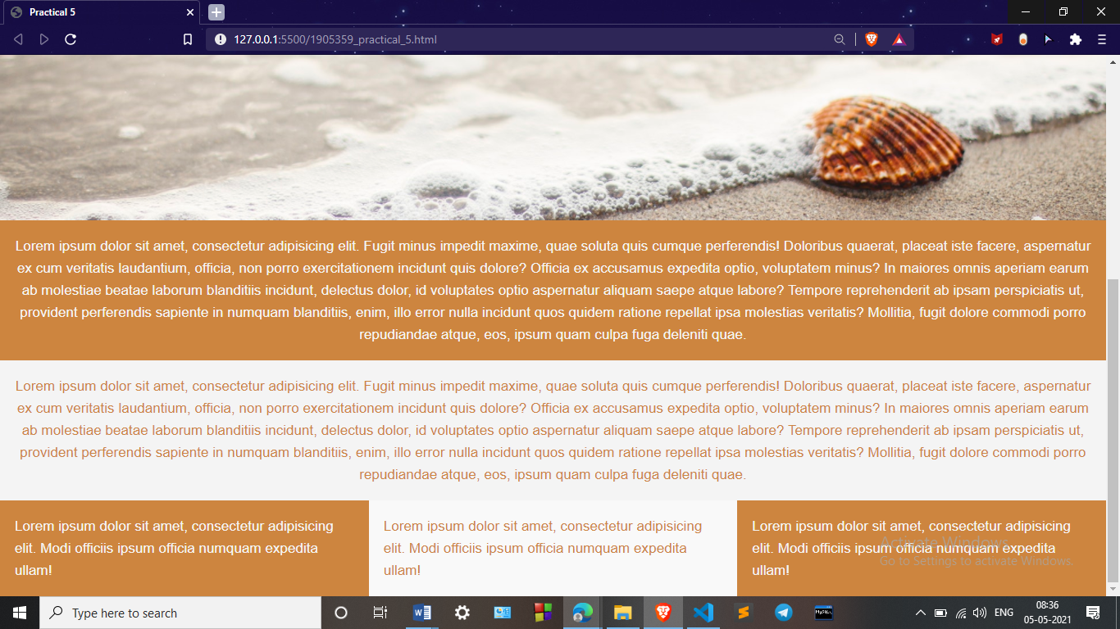

**Practical 6**

**Aim:** *Demonstrate the use of bootstrap framework*

**Code: HTML CODE**

<!doctype *html*>

<html *lang*="en">

<head>

    <!-- Required meta tags -->

    <meta *charset*="utf-8">

    <meta *name*="viewport" *content*="width=device-width, initial-scale=1, shrink-to-fit=no">

    <!-- Bootstrap CSS -->

    <link *rel*="stylesheet" *href*="https://stackpath.bootstrapcdn.com/bootstrap/4.1.3/css/bootstrap.min.css"

*integrity*="sha384-MCw98/SFnGE8fJT3GXwEOngsV7Zt27NXFoaoApmYm81iuXoPkFOJwJ8ERdknLPMO" *crossorigin*="anonymous">

    <title>Practical 6</title>

</head>

<body>

    <nav *class*="navbar navbar-expand-lg navbar-dark bg-dark">

        <a *class*="navbar-brand" *href*="#">WT</a>

        <button *class*="navbar-toggler" *type*="button" *data-toggle*="collapse" *data-target*="#navbarSupportedContent"

*aria-controls*="navbarSupportedContent" *aria-expanded*="false" *aria-label*="Toggle navigation">

            <span *class*="navbar-toggler-icon"></span>

        </button>

        <div *class*="collapse navbar-collapse" *id*="navbarSupportedContent">

            <ul *class*="navbar-nav mr-auto">

                <li *class*="nav-item active">

                    <a *class*="nav-link" *href*="#">Home <span *class*="sr-only">(current)</span></a>

                </li>

                <li *class*="nav-item">

                    <a *class*="nav-link" *href*="#">About</a>

                </li>

                <li *class*="nav-item dropdown">

                    <a *class*="nav-link dropdown-toggle" *href*="#" *id*="navbarDropdown" *role*="button"

*data-toggle*="dropdown" *aria-haspopup*="true" *aria-expanded*="false">

                        Topics

                    </a>

                    <div *class*="dropdown-menu" *aria-labelledby*="navbarDropdown">

                        <a *class*="dropdown-item" *href*="#">HTML</a>

                        <a *class*="dropdown-item" *href*="#">CSS</a>

                        <div *class*="dropdown-divider">JavaScript</div>

                        <a *class*="dropdown-item" *href*="#">Jquery</a>

                        <a *class*="dropdown-item" *href*="#">Ajax</a>

                        <div *class*="dropdown-divider"></div>

                        <a *class*="dropdown-item" *href*="#">PHP</a>

                        <a *class*="dropdown-item" *href*="#">Bootstrap</a>

                    </div>

                </li>

                <li *class*="nav-item">

                    <a *class*="nav-link" *href*="#">Contact Us</a>

                </li>

            </ul>

            <form *class*="form-inline my-2 my-lg-0">

                <input *class*="form-control mr-sm-2" *type*="search" *placeholder*="Search" *aria-label*="Search">

                <button *class*="btn btn-outline-success my-2 my-sm-0" *type*="submit">Search</button>

            </form>

        </div>

    </nav>

    <div *id*="carouselExampleIndicators" *class*="carousel slide carousel-fade" *data-ride*="carousel">

        <ol *class*="carousel-indicators">

            <li *data-target*="#carouselExampleIndicators" *data-slide-to*="0" *class*="active"></li>

            <li *data-target*="#carouselExampleIndicators" *data-slide-to*="1"></li>

            <li *data-target*="#carouselExampleIndicators" *data-slide-to*="2"></li>

        </ol>

        <div *class*="carousel-inner">

            <div *class*="carousel-item active">

                <img *class*="d-block w-100" *src*="https://source.unsplash.com/1400x300/?nature,water" *alt*="First slide">

                <div *class*="carousel-caption d-none d-md-block">

                    <h2>First slide label</h2>

                    <p>Lorem Ipsum is simply dummy text of the printing and typesetting industry.</p>

                    <button *class*="btn btn-danger">Technology</button>

                    <button *class*="btn btn-primary">Web Development</button>

                    <button *class*="btn btn-success">Tech Fun</button>

                </div>

            </div>

            <div *class*="carousel-item">

                <img *class*="d-block w-100" *src*="https://source.unsplash.com/1400x300/?nature,python" *alt*="Second slide">

                <div *class*="carousel-caption d-none d-md-block">

                    <h2>second slide label</h2>

                    <p>It is a long established fact that a reader will be distracted by the readable content of a page

                        when looking at its layout. </p>

                    <button *class*="btn btn-danger">Technology</button>

                    <button *class*="btn btn-primary">Web Development</button>

                    <button *class*="btn btn-success">Tech Fun</button>

                </div>

            </div>

            <div *class*="carousel-item">

                <img *class*="d-block w-100" *src*="https://source.unsplash.com/1400x300/?nature,code" *alt*="Third slide">

                <div *class*="carousel-caption d-none d-md-block">

                    <h2>Third slide label</h2>

                    <p>There is no one who loves pain itself, who seeks after it and wants to have it, simply because it

                        is pain...</p>

                    <button *class*="btn btn-danger">Technology</button>

                    <button *class*="btn btn-primary">Web Development</button>

                    <button *class*="btn btn-success">Tech Fun</button>

                </div>

            </div>

        </div>

        <a *class*="carousel-control-prev" *href*="#carouselExampleIndicators" *role*="button" *data-slide*="prev">

            <span *class*="carousel-control-prev-icon" *aria-hidden*="true"></span>

            <span *class*="sr-only">Previous</span>

        </a>

        <a *class*="carousel-control-next" *href*="#carouselExampleIndicators" *role*="button" *data-slide*="next">

            <span *class*="carousel-control-next-icon" *aria-hidden*="true"></span>

            <span *class*="sr-only">Next</span>

        </a>

    </div>

    <div *class*="container my-4">

        <div *class*="row mb-2">

            <div *class*="col-md-6">

                <div *class*="card flex-md-row mb-4 shadow-sm h-md-250">

                    <div *class*="card-body d-flex flex-column align-items-start">

                        <strong *class*="d-inline-block mb-2 text-primary">PHP</strong>

                        <p *class*="card-text mb-auto">Lorem Ipsum is simply dummy text of the printing and typesetting industry.</p>

                        <a *href*="#">Continue reading</a>

                    </div>

                    <img *class*="card-img-right flex-auto d-none d-lg-block" *data-src*="holder.js/200x250?theme=thumb"

*alt*="Thumbnail [200x250]" *style*="width: 200px; height: 250px;"

*src*="https://source.unsplash.com/500x700/?nature,water" *data-holder-rendered*="true">

                </div>

            </div>

            <div *class*="col-md-6">

                <div *class*="card flex-md-row mb-4 shadow-sm h-md-250">

                    <div *class*="card-body d-flex flex-column align-items-start">

                        <strong *class*="d-inline-block mb-2 text-success">JavaScript</strong>

                        <p *class*="card-text mb-auto">Lorem Ipsum is simply dummy text of the printing and typesetting industry.</p>

                        <a *href*="#">Continue reading</a>

                    </div>

                    <img *class*="card-img-right flex-auto d-none d-lg-block" *data-src*="holder.js/200x250?theme=thumb"

*alt*="Thumbnail [200x250]" *src*="https://source.unsplash.com/500x700/?nature,technology"

*data-holder-rendered*="true" *style*="width: 200px; height: 250px;">

                </div>

            </div>

        </div>

    </div>

    <!-- Optional JavaScript -->

    <!-- jQuery first, then Popper.js, then Bootstrap JS -->

    <script *src*="https://code.jquery.com/jquery-3.3.1.slim.min.js" *integrity*="sha384-q8i/X+965DzO0rT7abK41JStQIAqVgRVzpbzo5smXKp4YfRvH+8abtTE1Pi6jizo" *crossorigin*="anonymous"></script>

    <script *src*="https://cdnjs.cloudflare.com/ajax/libs/popper.js/1.14.3/umd/popper.min.js" *integrity*="sha384-ZMP7rVo3mIykV+2+9J3UJ46jBk0WLaUAdn689aCwoqbBJiSnjAK/l8WvCWPIPm49" *crossorigin*="anonymous"></script>

    <script *src*="https://stackpath.bootstrapcdn.com/bootstrap/4.1.3/js/bootstrap.min.js" *integrity*="sha384-ChfqqxuZUCnJSK3+MXmPNIyE6ZbWh2IMqE241rYiqJxyMiZ6OW/JmZQ5stwEULTy" *crossorigin*="anonymous"></script>

</body>

</html>

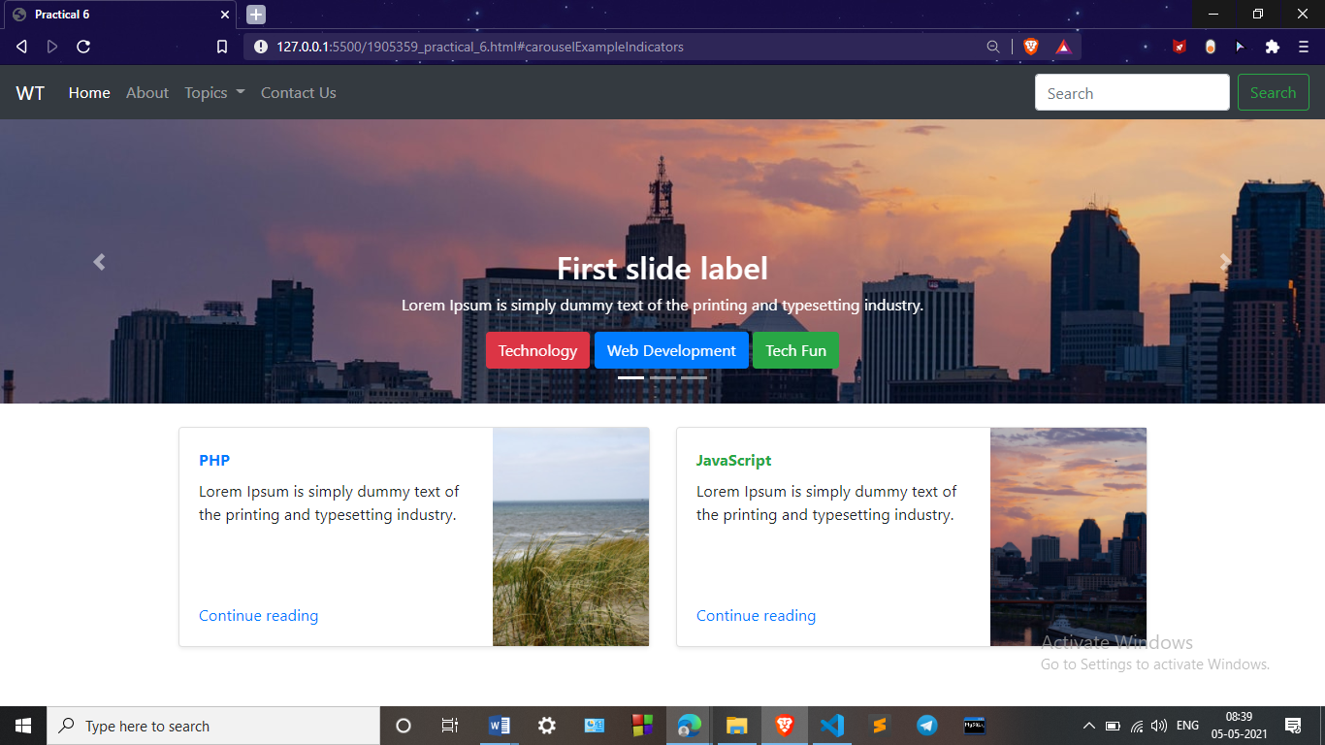**OUTPUT-**

**Practical 7**

**Aim:** *Creating a web page using php*

**Code: PHP CODE**

<!DOCTYPE *html*>

<html *lang*="en">

<head>

    <link *rel*="stylesheet" *href*="1905359_practical_7.css" *type*="text/css">

    <title>Practical 7</title>

    <meta *charset*="UTF-8">

    <meta *http-equiv*="X-UA-Compatible" *content*="IE=edge">

    <meta *name*="viewport" *content*="width=device-width, initial-scale=1.0">

</head>

<?php

// define variables and set to empty values

$name = $email = $gender = $desc = $interests = $about ="";

if ($_SERVER["REQUEST_METHOD"] == "POST") {

  $name = test_input($_POST["name"]);

  $email = test_input($_POST["email"]);

  $gender = test_input($_POST["gender"]);

  $desc = test_input($_POST["desc"]);

  $interests = test_input($_POST["interests"]);

  $interets = test_input($_POST["about"]);

}

function test_input($data) {

  $data = trim($data);

  $data = stripslashes($data);

  $data = htmlspecialchars($data);

  return $data;

}

?>

<body>

    <div *class*="form1">

        <form *method*="POST" *action*="<?php echo htmlspecialchars($_SERVER["PHP_SELF"]);?>">

            <fieldset>

                <legend><span *class*="number">1</span>Candidate Info</legend>

                <input *type*="text" *name*="name" *placeholder*="Your Name * "><br>

                <input *type*="email" *name*="email" *placeholder*="Your Email * "><br>

                    <label>Gender: </label>

                    <label *for*="male"><span><input *type*="radio" *value*="male" *name*="gender" *value*="male">Male</span></label>

                    <label *for*="female"><span><input *type*="radio" *value*="female" *name*="gender"

*value*="female">Female</span></label>

                    <label *for*="other"><span><input *type*="radio" *value*="other" *name*="gender"

*value*="other">Other</span></label>

                <textarea *name*="desc" *placeholder*="Describe Yourself"></textarea><br>

                <label *for*="job">Interests: </label>

                <select *name*="interests" *id*="job">

                    <optgroup *label*="Indoors">

                        <option *value*="Fishkeeping">Fishkeeping</option>

                        <option *value*="Reading">Reading</option>

                        <option *value*="Boxing">Boxing</option>

                        <option *value*="Debate">Debate</option>

                        <option *value*="Gaming">Gaming</option>

                        <option *value*="Snooker">Snooker</option>

                        <option *value*="Other_indoor">Other</option>

                    </optgroup>

                    <optgroup *label*="Outdoors">

                        <option *value*="Football">Football</option>

                        <option *value*="Swimming">Swimming</option>

                        <option *value*="Fishing">Fishing</option>

                        <option *value*="Climbing">Climbing</option>

                        <option *value*="Cycling">Cycling</option>

                        <option *value*="Other_indoor">Other</option>

                    </optgroup>

                </select>

            </fieldset>

            <fieldset>

                <legend><span *class*="number">2</span>Candidate Info</legend>

                <textarea *name*="about" *placeholder*="About Your school: "></textarea>

            </fieldset>

            <input *type*="submit" *value*="Submit">

        </form>

    </div>

<?php

    echo "<h2>Your Input:</h2>";

    echo "Your Name: ";

    echo $name;

    echo "<br>";

    echo "Your Mail: ";

    echo $email;

    echo "<br>";

    echo "Your Gender: ";

    echo $gender;

    echo "<br>";

    echo "Your Description: ";

    echo $desc;

    echo "<br>";

    echo "Your about: ";

    echo $about;

    echo "<br>";

    echo "Your interests: ";

    echo $interests;

    echo "<br>";?>

</body>

</html>

**CSS CODE**

**\*\*Note-** Same as in practical 3 (form is same php is added to the Practical 3)

**OUTPUT-**

**Form INPUT**

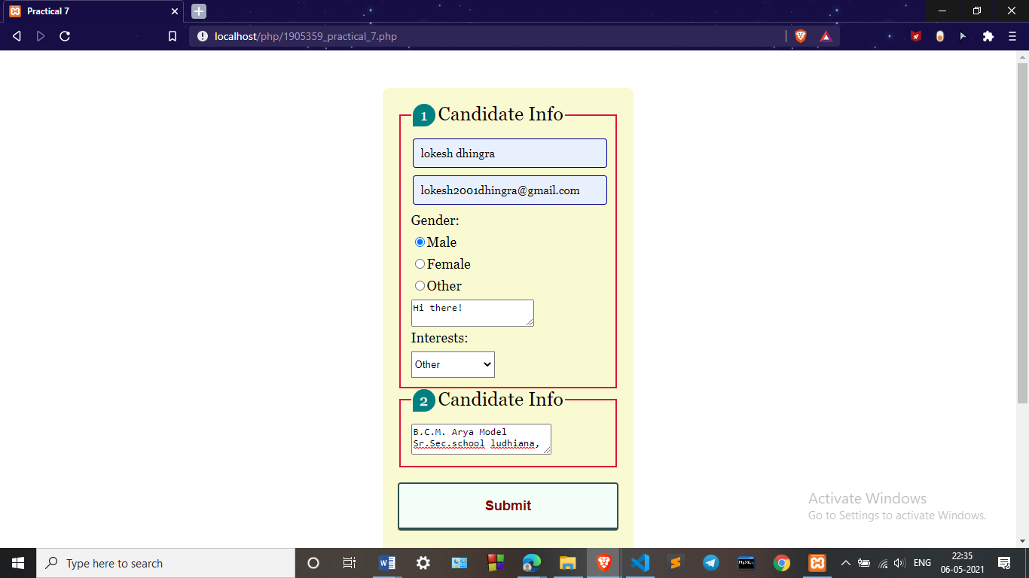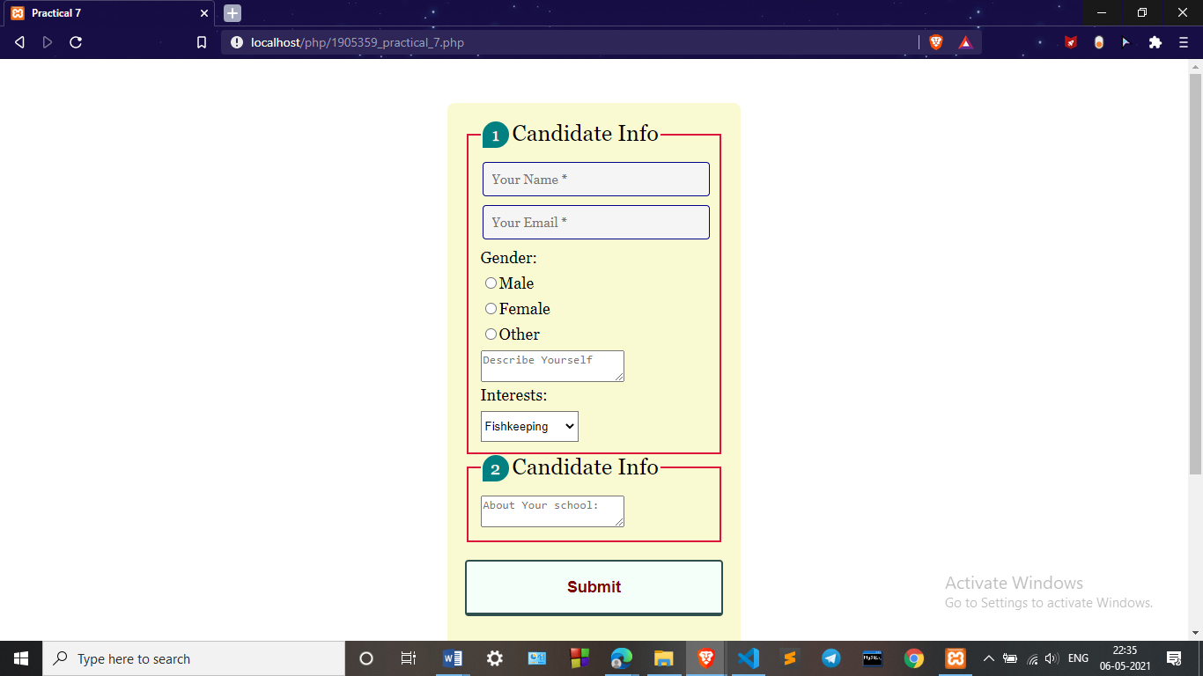

**OUTPUT-**

